Why become a CHANGE ambassador?
As a CHANGE Student Ambassador, you want to positively contribute to your schools and local communities. Your objective is to raise awareness about the importance of welcoming refugees and shaping a society where everyone can participate.

You develop ideas, define goals, plan actions and act together with other Student Ambassadors. Each Student Ambassador group will plan and carry out two actions.

Here below you will find methods and tips on how to develop an idea and a plan for your action, as well as on how to evaluate your actions.

STEP
What has become important to me and what could I do?
To start, it is important to reflect on what you have learned throughout the CHANGE course. To start, you can go through your reflection assignments: the pictures you took, the questions you have written down.

Next, to reflect further, answer these questions individually:

- What struck me the most?

- After CHANGE, I would like to learn more about…

- After CHANGE, I would like to do something about…

STEP
Starting points for action in our everyday life

To develop some ideas for your action, it helps to firstly identify a need for change. A need for change is a good starting point for an action. Answer the questions below with your group:

- Where do I see a need for change regarding refugees and migration? For example: in my school, in my sports club, in my youth movement, in my neighborhood etc.

- What needs to change?

You can now create a list of concrete starting points for action. Please keep these in mind for the following exercise.
Now it’s time to think about an action that can respond to this need for change. Let’s get started.
There are different types of action areas you could focus on:

Meeting and exchanging

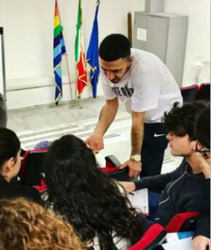
Actions that enable you to encounter and accompany refugees, perhaps through volunteering or through a service project.

Awareness-raising
Actions through which you share what you have learned about the positive aspects of migration, maybe through a small campaign on social media or an event you organise in your school or neighborhood.

Advocacy

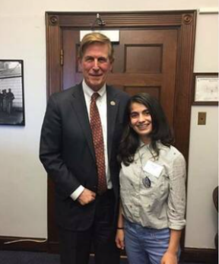
Actions through which you share what you have learned with your local political leaders and tell them about the change you want to make.

Feel free to come up with your own ideas!

If you need an extra hand, answering the following questions may guide you in thinking about an action:

- How could I meet more people with a refugee background?

- Do I know any organisations that work with refugees and/or migrants?

- Do I know of any existing (local) projects or initiatives which welcome and support refugees and/or migrants?

After a brainstorming session, list three ideas of actions you have:

1.

2.

3.

STEP
Planning - Who? When? How? Where?

Now you can turn your idea into action by using the Action Plan below. Draw out your action plan on a big poster. Make sure it’s visible as you will present it in the next step.
ACTION PLAN
ACTION AREA
(Accompaniment & Support, Awareness Raising or Advocacy)
OUR ACTION
THE CHANGE
WE WANT TO CREATE
THROUGH THE ACTION

WHAT WE NEED TO DO | WHAT WE PLAN | RESULTS - WHAT ACTUALLY HAPPENED?
GOALS:
- What goal(s) do we want to achieve?
- What will be different after our action than before?
- What change will we have achieved?
- Describe the goal concretely so that you can check whether and to what extent you have achieved it.

PERSONAL GOALS:
- What goals for ourselves do we want to achieve?
- What do we want to learn and practice?
- What change in ourselves do we expect?

DESCRIPTION OF THE ACTION:
- What do we want to do?
- Describe the action and the specific activities needed to achieve your goals.

TIMELINE:
- When will the action start?
- What day(s) should what take place?
- When will everything be completed?
RESPONSIBILITIES:
- Who is responsible for what activities?
- Is there one person who is in charge overall? Does everyone have a role that matches his or her own skills and interests?
RESOURCES:
- What resources do we need to achieve the activities and achieve the goal?
- List exactly the resources you need (technology, physical spaces, extra materials, money).

SUPPORT:
- Which partners, sponsors and other people can help and support us?

ADVERTISING:
- How can we advertise our action and communicate about it in advance?
- Which tools (social media, posters, flyers etc.) do we need to make the action visible?

COMMUNICATING RESULTS:
- How will we communicate the results of the action with others?
- Appoint someone to take photos during the action – other options are live streaming on social media or asking a journalist to report on the action.

Pitch your action plan in the “Market of Possibilities”
STEP

You will now participate in a market of possibilities. Together with your group, you will present your action to the rest of the classmates and discuss the idea at a table or flipchart. You will also walk around from one proposal to another to discover and discuss the other groups’ action plans.

The objective of the market is to compare the different action ideas, to discuss them and provide feedback.

After the market, write down 2 action plans that you would like to engage with:

1.

2.

STEP
Carry out your action

- Based on your action plan, you are ready to get started to make your action a reality.
- Stick to the timeline you planned.
- Communication with your Student Ambassador group is key! Talk together about your action plan.
- You will probably need to adjust the action plan, that’s okay. Remember that careful planning is important but planning cannot foresee everything!
- Remember to ask for support from your teacher, moderator or CHANGE partner when you need it.
- Keep track of your results. Do not hesitate to talk about the process and results of your action with people around you in different ways:
  - In your school’s newspaper, website or social media. You could write an article or record a video explaining the impact of your action.
  - On social media: you can post photos, videos and messages on Instagram, Facebook and Twitter using the hashtag #IAMCHANGE and #ACT4CHANGE.

This way, you can inspire other people to take action!

STEP

Reflection on your action

After completing your action, answer the following questions.

- What did we want to achieve with our action?

- What have we achieved? How satisfied are we with the result?

- How did I feel during the action? What made me joyful, what was difficult or disappointing?

- What did I learn from the action - about society, about other people, about myself?

- Have I changed - and if so, in what regard?

